DENSO in motorsport

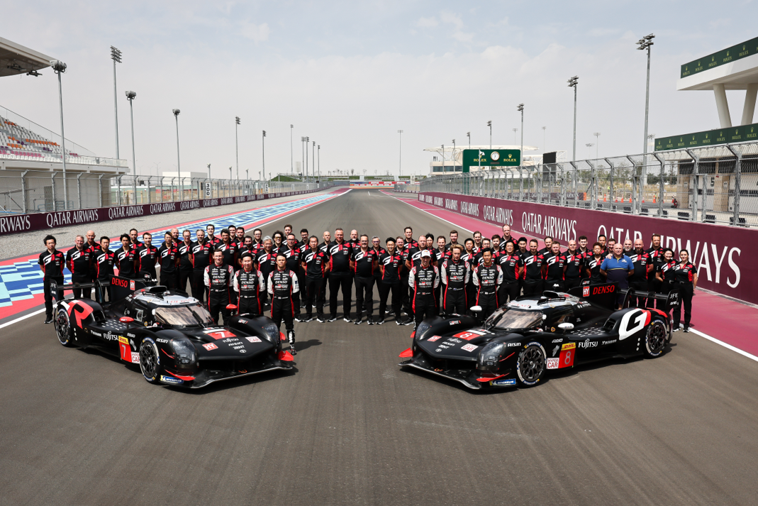
DENSO’s partnership with TOYOTA GAZOO Racing (TGR) aims to advance sustainable motorsport through cutting-edge hybrid racing technology. By providing high-quality components and expertise in hybrid systems, DENSO plays a crucial role in enhancing the performance and reliability of TGR's race cars. This collaboration not only pushes the boundaries of motorsport but also translates these innovations into more efficient, eco-friendly passenger vehicles, ensuring that the advances made on the track benefit everyday drivers
As would be expected from a leading supplier of original equipment (OE) parts to vehicle manufacturers around the world, DENSO does not confine its support to one team or manufacturer. Within the motorcycle racing community, for example, it supports a variety of teams running machines from Honda, Kawasaki, Suzuki and Yamaha, in both world and regional championships.
When it comes to four wheel competition, DENSO’s support encompasses both circuit racing and offroad disciplines, and includes Super GT and rally championships etc., but reaches its pinnacle with the relationship it has with TGR.
DENSO and TGR have been in partnership for much of the last decade and together have achieved unprecedented success, most notably in the FIA World Endurance Championship (WEC) and World Rally Championship (WRC), where the combination are multiple championship winners
The TGR team and its Toyota hybrid machines compete in the Hypercar category of the WEC, that presents challenges from manufacturers such as Cadillac, Ferrari, Glickenhaus, Peugeot, Porsche and Vanwall, and in which it has achieved long term success over a sustained period, so emphasising the superiority of both the design and reliability of the car, as well as the organisational skills of the team and the pace of its drivers.
When it comes to the WRC, the partnership has enjoyed a similar level of domination, with multiple driver’s and manufacturer’s titles, most recently with the Toyota GR Yaris Rally1 Hybrid. Highlighting the in depth nature of this relationship and the results it yields, DENSO has produced a revealing video that focuses on how its thermal management expertise has played a central role.
DENSO’s reputation for manufacturing premium quality OE products for vehicle manufacturers globally, has made it a perfect fit for both the team and the Toyota machines it runs in both championships, as well as the other outfits it also supports in the various categories mentioned earlier.
These same parts are available to the independent service and repair sector through DENSO Aftermarket Europe, which ensures that world class OE replacement parts are available to motorists, so providing them with the reliability they seek, and the peace of mind they need.
Further details of the DENSO Aftermarket programme are available online at: www.denso-am.eu
ENDS
For more information, interviews or images please contact:

Germany Annina Oppinger, Externe Marketing & PR
email: annina.oppinger@externe-marketingabteilung.de

UK & IE Steve Coombes, Chicane
email: steve@chicane.marketing

Poland Dawid Dziwosz, Agencja Publink, Poland
email: ddziwosz@publink.com.pl

Ukraine Lika Kolomiets, Lika Design
email: lika@tgf.com.ua

Romania Victor Gavronschi, Loopaa
email: victor.gavronschi@loopaa.ro

Italy Ludovica Giusa, DENSO Aftermarket Italy
email: l.giusa@eu.denso.com

Spain/Portugal Pablo Rodriguez, DENSO Aftermarket Iberia
email: p.rodriguez@eu.denso.com

France Sonkalou Konate, DENSO Aftermarket France
email: s.konate@eu.denso.com

DENSO Europe Fatiha Laauich, DENSO Aftermarket Europe
email: f.laauich@eu.denso.com

