A new era of electrification: Supporting the European aftermarket

Collaborating with original equipment (OE) suppliers such as DENSO, can facilitate access to specialised replacement parts and provide the technical support they need to make the transition as smooth as possible
Vehicle manufacturers (VMs) universally have all had to respond to the demands of governments around the world, as they have committed their nations to reduce carbon emissions and greenhouse gases, for the sake of the environment and in an attempt to reduce rises in global temperatures. Collectively, the VMs have chosen electrification as the primary solution to these demands and so the growth in the number of new energy vehicles (NEVs) coming into the market has been phenomenal.

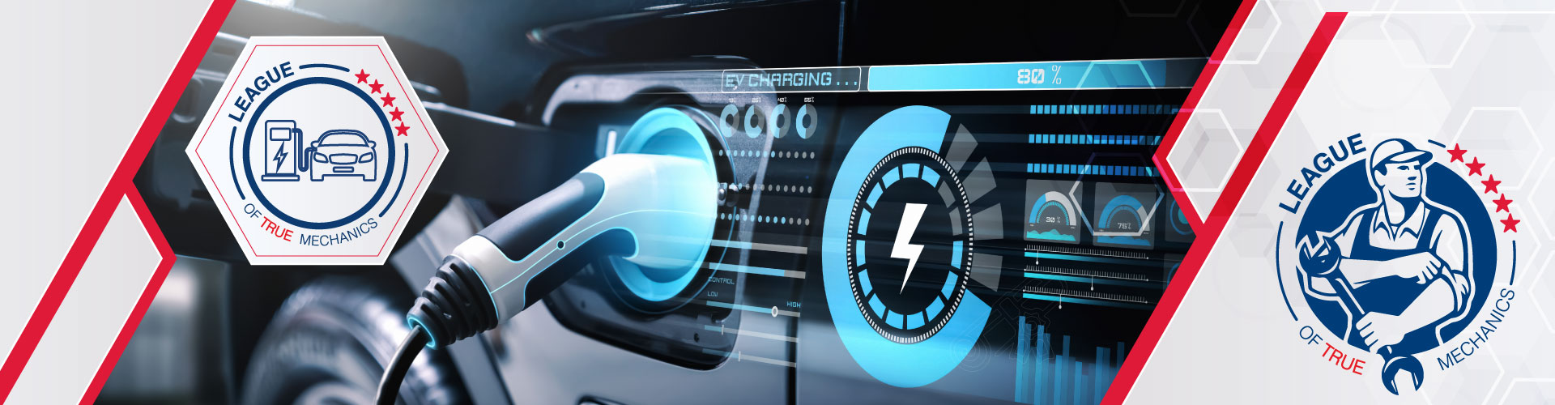
The transition to electrification brings significant challenges and opportunities for independent workshops and garages as they must acquire new skills and knowledge to work on these advanced vehicles safely and effectively. The intricate systems and high-voltage components found in NEVs require specialised training, without which technicians may face safety risks and operational inefficiencies. Consequently, staying updated on the latest developments in NEV technology is crucial for independent technicians to remain competitive in the evolving market.
To support this transition, DENSO has launched a new training module in its e-learning portal (www.denso-technic.com) focused on the basics of hybrid and electric vehicles. This module offers technicians essential knowledge about the components and functionalities of NEVs, as well as the necessary safety precautions and skills for handling these vehicles. By providing this training, DENSO is empowering independent technicians to adapt to the electrification era.
By collaborating closely with its OE and R&D teams, DENSO Aftermarket gains direct access to cutting-edge knowledge of new powertrain systems and real-time data on the demand for emerging types of replacement components. This insight enables DENSO to anticipate future needs and adapt its aftermarket portfolio to meet the growing demand for NEV-related services, ensuring that independent workshops are well-equipped to thrive in the evolving automotive landscape.
While there are significant differences when it comes to their power units and drivetrain, there are still many similarities between NEVs and traditional petrol and diesel powered vehicles when it comes to their driving comfort and safety, for example.
Both of these areas are DENSO OE specialisms, which is why there should be no surprise that air conditioning (AC) products, including cabin filters, as well as wiper blades, form a large part of its NEV replacement parts offering.
Electrification also presents significant opportunities for aftermarket businesses. The increasing complexity of NEVs creates demand for specialised aftermarket services, such as battery maintenance and software updates, but also for AC service and repair.
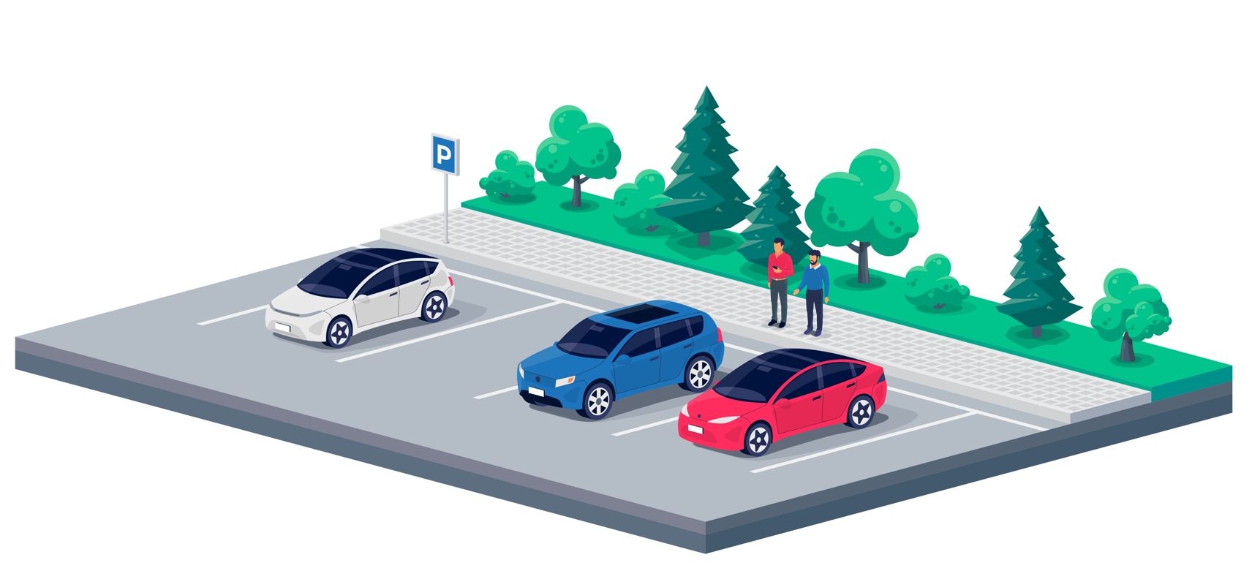
To thrive in the era of electrification, aftermarket businesses must embrace innovation and adaptability. Investing in training programmes and acquiring the necessary expertise in NEV technology is essential for staying competitive in the market.
For further details of the DENSO Aftermarket sustainability programme, please visit DENSO-AM website.
ENDS
For more information, interviews or images please contact:

Germany Annina Oppinger, Externe Marketing & PR
email: annina.oppinger@externe-marketingabteilung.de

UK & IE Steve Coombes, Chicane
email: steve@chicane.marketing

Poland Dawid Dziwosz, Agencja Publink, Poland
email: ddziwosz@publink.com.pl

Ukraine Lika Kolomiets, Lika Design
email: lika@tgf.com.ua

Romania Victor Gavronschi, Loopaa
email: victor.gavronschi@loopaa.ro

Italy Ludovica Giusa, DENSO Aftermarket Italy
email: l.giusa@eu.denso.com

Spain/Portugal Pablo Rodriguez, DENSO Aftermarket Iberia
email: p.rodriguez@eu.denso.com

France Sonkalou Konate, DENSO Aftermarket France
email: s.konate@eu.denso.com

DENSO Europe Fatiha Laauich, DENSO Aftermarket Europe
email: f.laauich@eu.denso.com

